

**CSE423: Computer Graphics**

**Lab** **Assignment 1**

**Important Instructions for the Assignment:**

* Before starting this assignment, please ensure you have installed the mentioned OpenGL libraries in your System.
* The skeleton code is provided for completing the tasks, or you can design your own.
* For submission, **students need to submit a single .py file for an assignment. In case of multiple tasks in an assignment, you will comment out one task and show the other in a single py file. You need to rename the single py file for submission into ID_name_assignmentNo.py (ex. 17003456_md x_01.py) and submit it. Failing to follow the appropriate format in submitting will yield -20% penalty.**
* The deadline for submission is to be strictly maintained. **Late submissions will not be accepted.**
* **You must attend the lab viva for each assignment. Otherwise, you won’t get any lab marks for that assignment.**
* Any form of plagiarism will automatically cancel your assignment and will be awarded with a **-100%** mark.. Please refrain from such activities.

**Task 1: Building a House in Rainfall**

1. Draw a **house with a raindrop** using the base primitives: points, lines, or triangles. You can use **ONLY** ***GL_POINTS***, ***GL_LINES,*** or ***GL_TRIANGLES*** for designing this house. A diagram has been provided as an example. **You can modify the house design to your liking. The rain drops should be animated to fall from top to bottom.**
2. It has been raining unwantedly for the last few days, so let’s control its direction by designing a key that will change the direction of the rain when clicked (slightly bending the rainfall). Design this functionality such that the **left arrow** will gradually bend the rain to the left and the **right arrow** will gradually bend the rain to the right.
3. Formulate two more keys(**assign whatever key you like**); pressing one will gradually change the skin colour from dark to light simulating night to day, and the other will change it from light to dark simulating day to night . You must also consider the rain and the house visibility in different background colours.

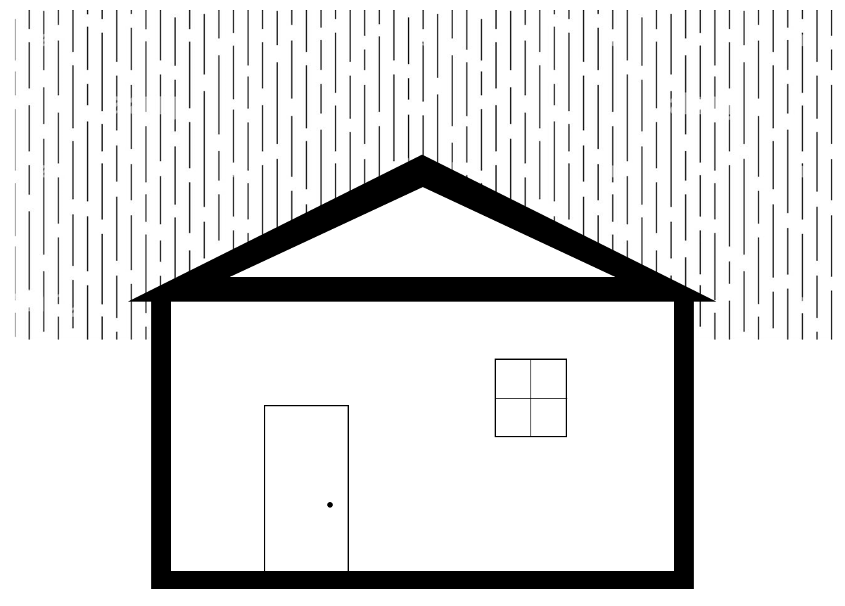

**Task 2: Building the Amazing Box**

Design a box with the following functionalities and ensure they all work independently and in any combination. Check out the gifs along with instructions for better understanding.

1. The **right button** click on a mouse will generate random movable points with different colours going **in any random direction diagonally within a boundary region**. For instance, if a point is generated at (0,0), it can go to (-1, 1), (-1, -1), (1,1), or (1, -1), and so on. The points should be spawned where the **right button** click will be given in the box and the colour and direction of movement should be random. **The points will continue to move in the same direction and will bounce back from the wall of the boundary. [Bouncing from the wall can be implemented by changing the sign of corresponding position update parameter]**
2. Pressing the “**up arrow**” key on the keyboard will increase the speed of all the points generated so far and pressing the “**down arrow**” key on the keyboard will decrease the speed.
3. The **left button** click on a mouse will make the points blink i.e. if a point is in red, it will go background color(here it’s black) and return to red, and this transition should take place within a second while the transition cycle goes on. [Think how you can easily implement this]
4. Pressing the “**Spacebar”** on the keyboard should freeze all the points and none of the above functionalities will work when frozen. The same “**Spacebar**” should unfreeze them.



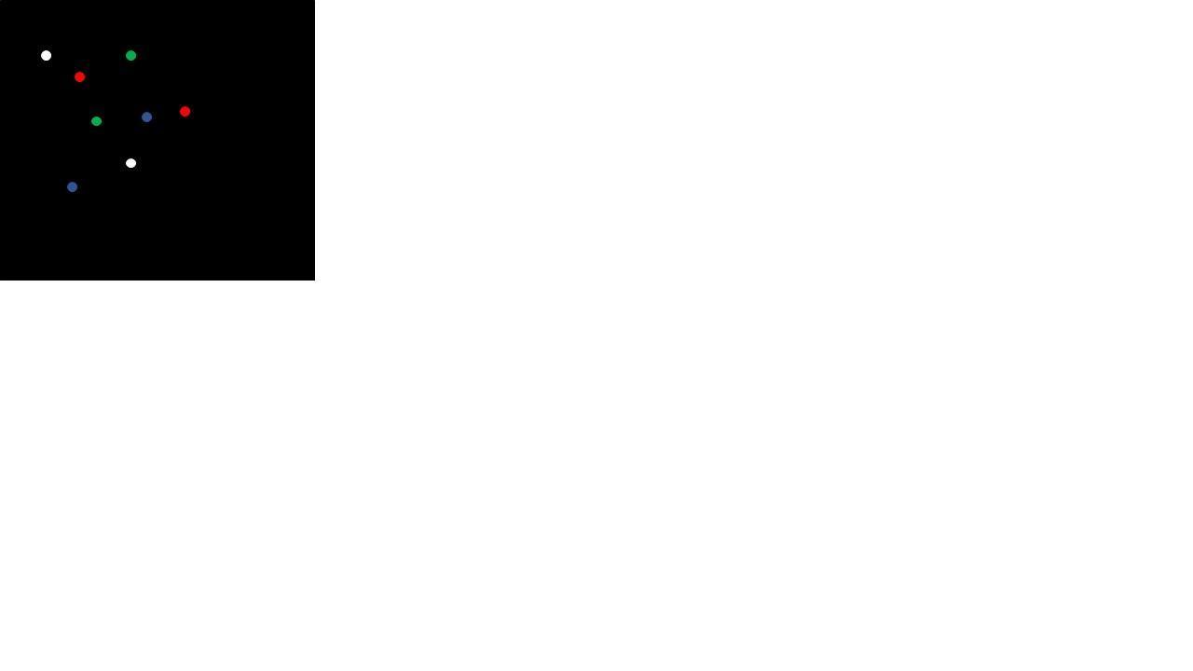

Above pictures don’t depict the full scenario

**Submission guideline**: You have to submit it in the classroom. Please follow the submission instructions carefully. Failure to follow will be subject to a mark penalty (20% to 50%).